**III. BUILD AND EVOLVE AGILE TEAMS**

Introduction

Lesson Introduction

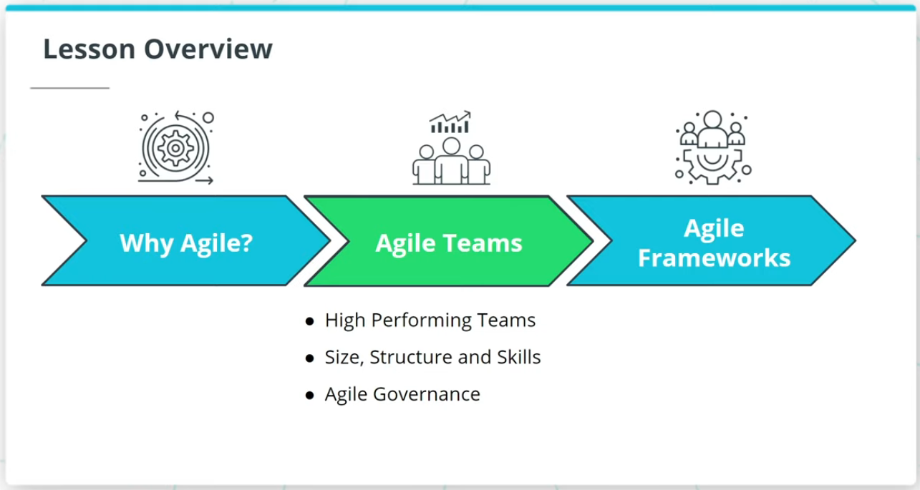

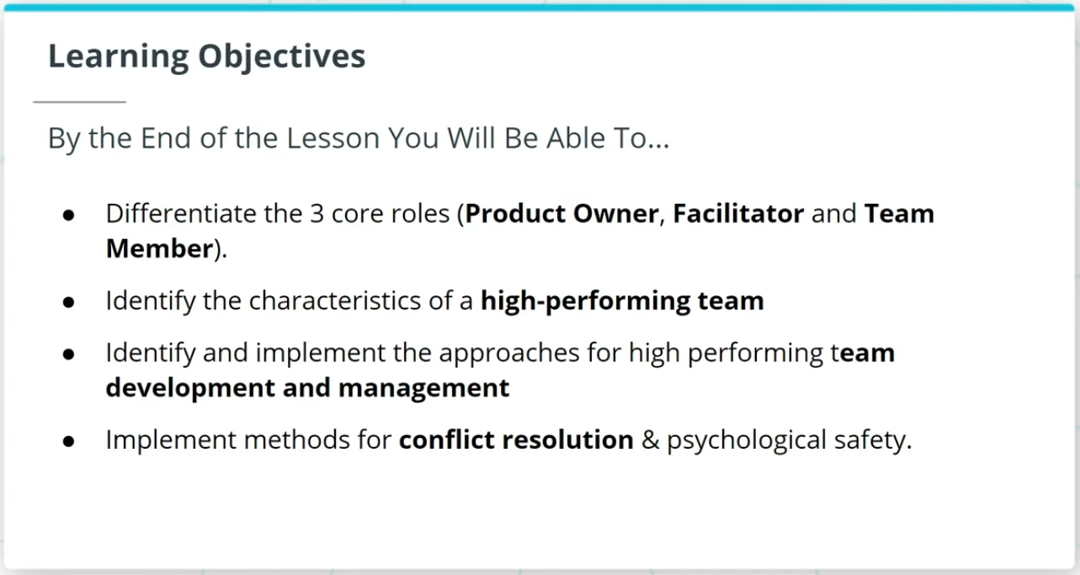

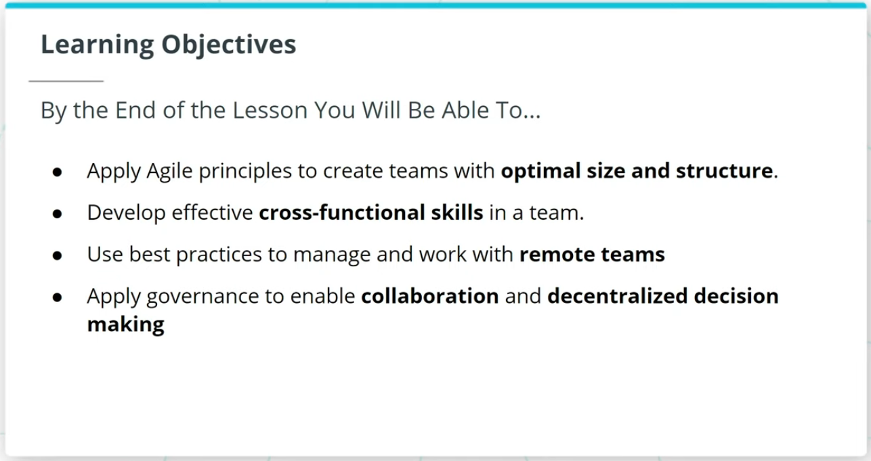

Welcome to a lesson on Agile Teams. In the last lesson, we talked about the importance of Agile.

This lesson will cover the following key topics:

### **High Performing Agile Teams**

* How Agile Teams are the vehicle that delivers valuable work tied to business-driven product features and functionality.
* Characteristics of a high-performing Agile Team.
* How to sustain High Performing Teams.

### **Size, Structure, and Skills of an Agile Team**

* The 3 core roles in Agile.
* An Agile Team’s optimal size, structure, and cross-functional skills.

### **Agile Governance**

* Agile Governance and how Agile governance leverages The Agile Manifesto’s guidelines to balance assurance with adaptability.

### **By the End of the Lesson, You Will Be Able To...**

* Differentiate the 3 core roles (Product Owner, Facilitator, and Team Member)
* Identify the characteristics of a high-performing team
* Identify and implement the approaches for high performing team development and management
* Implement methods for conflict resolution & psychological safety
* Apply Agile principles to create teams with optimal size and structure
* Develop effective cross-functional skills in a team
* Use best practices to manage and work with remote teams
* Apply governance to enable collaboration and decentralized decision making

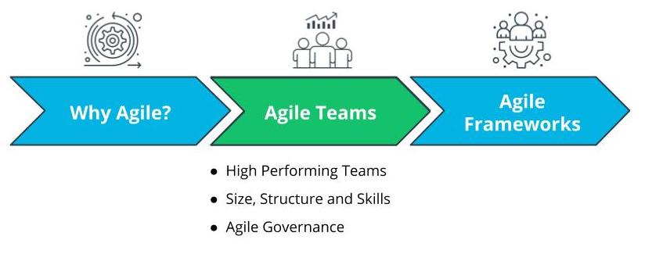

Lesson Overview - Agile Teams

# Why Agile Teams?

## Why Do Agile Teams Matter?

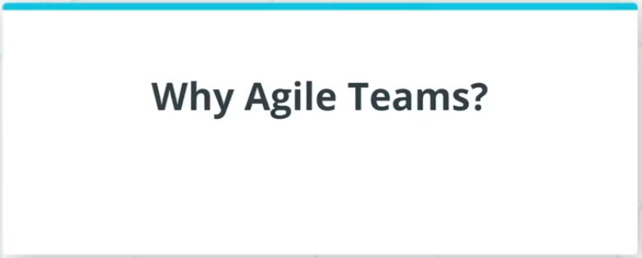

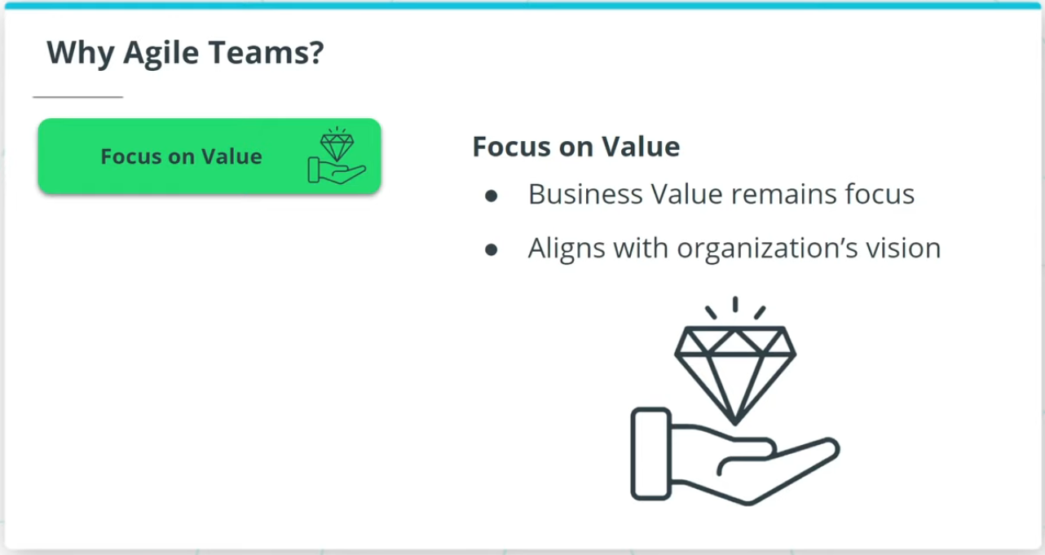

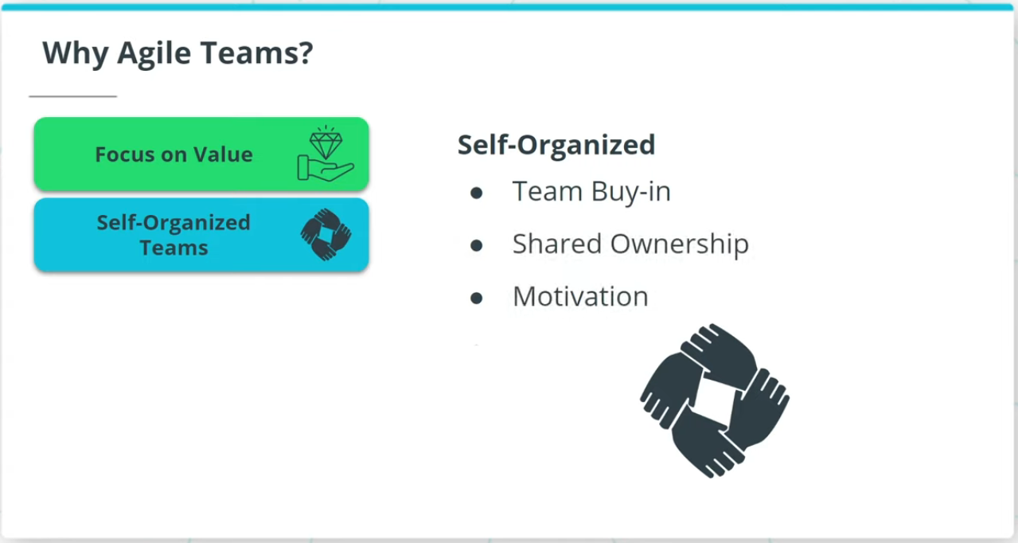

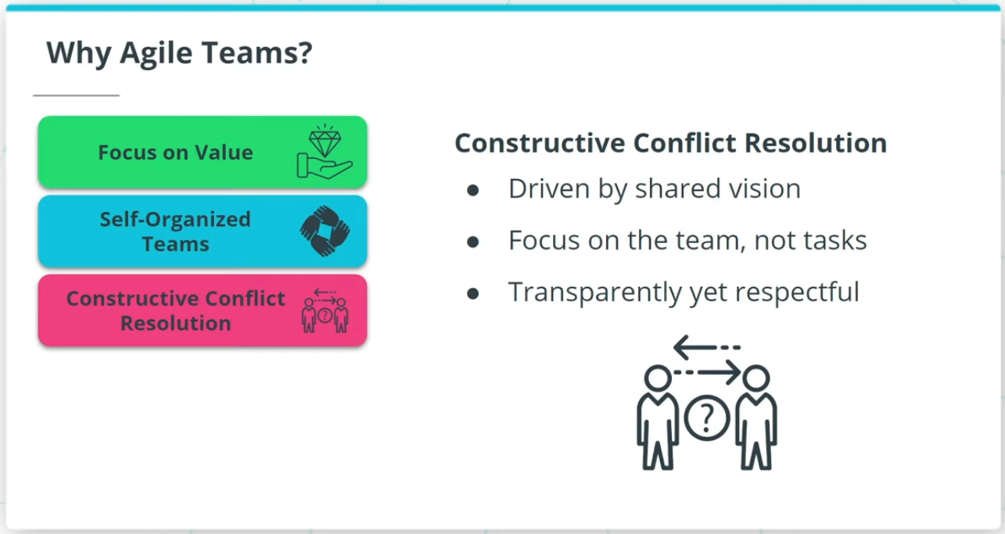

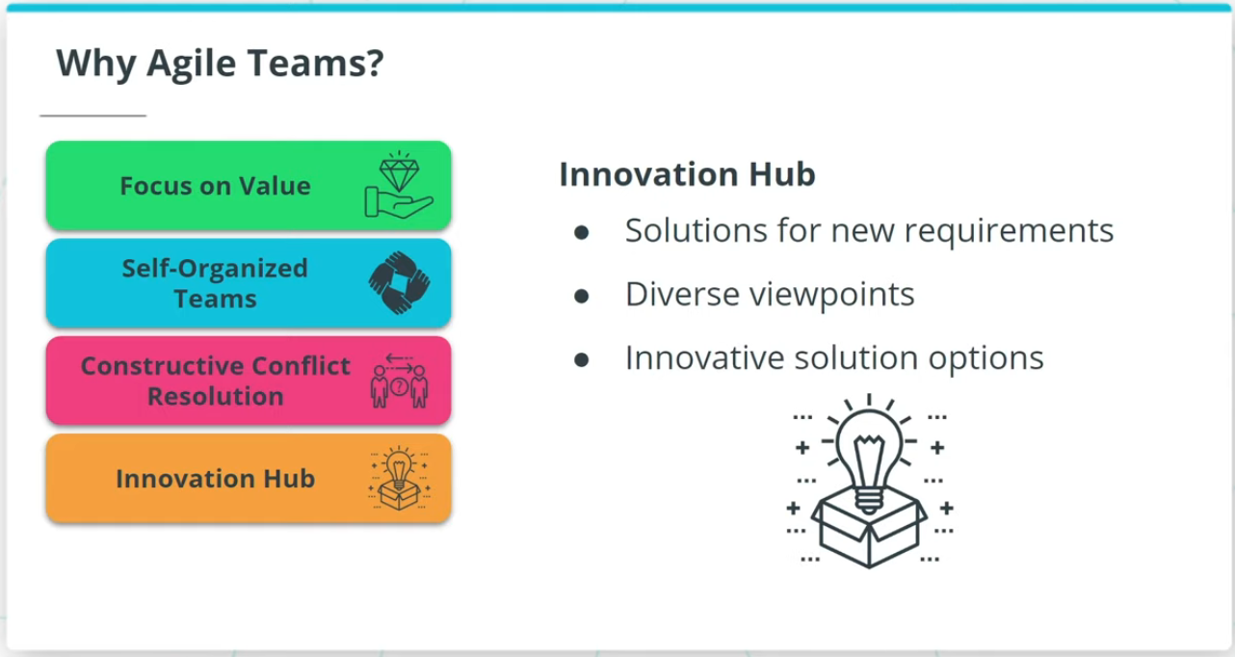

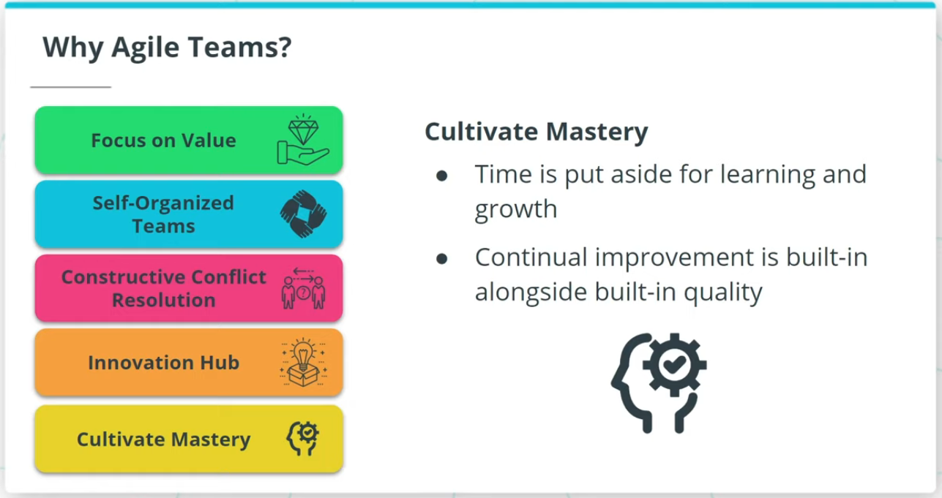

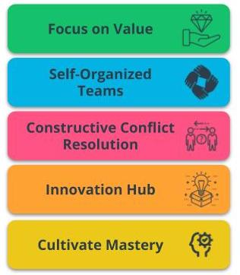

Benefits of Agile Teams

### **Agile Teams are a critical vehicle to deliver valuable results because of the following:**

* **Focus on Value** - Agile is driven by the goal of delivering maximum business value that is aligned with the organization’s vision.
* **Self-Organized Teams** - Agile Teams have the autonomy to make some de-centralized decisions, which allows for shared ownership of the work.
* **Constructive Conflict Resolution** - Conflicts in Agile Teams are constructively resolved because the team is driven by a shared vision.
* **Innovation Hub** - Agile Teams, with diverse and cross-functional skill sets, are an innovation hub that spurs solutions.
* **Cultivate Mastery** - Time is put aside in Agile Teams for learning and growth. This allows Agile Team members to sharpen their skills.

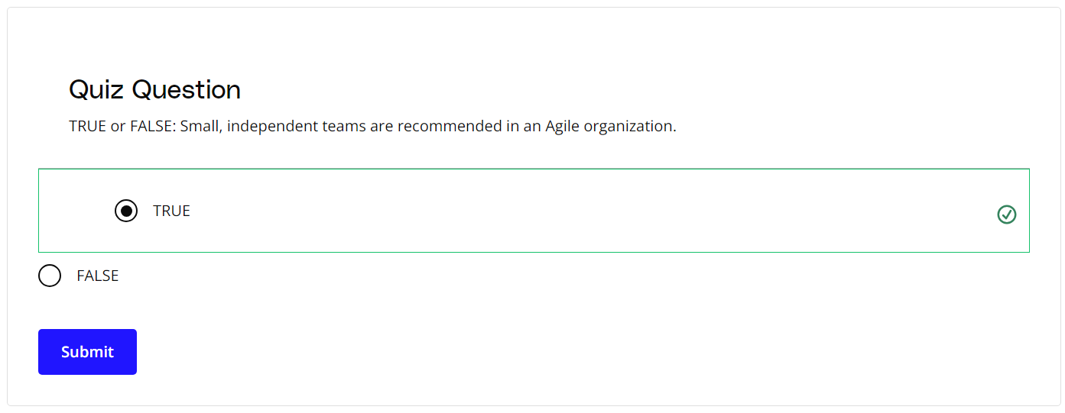

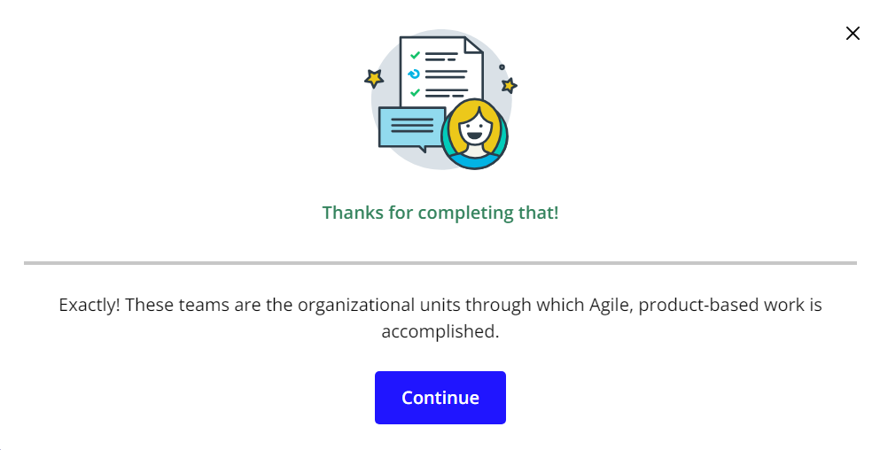

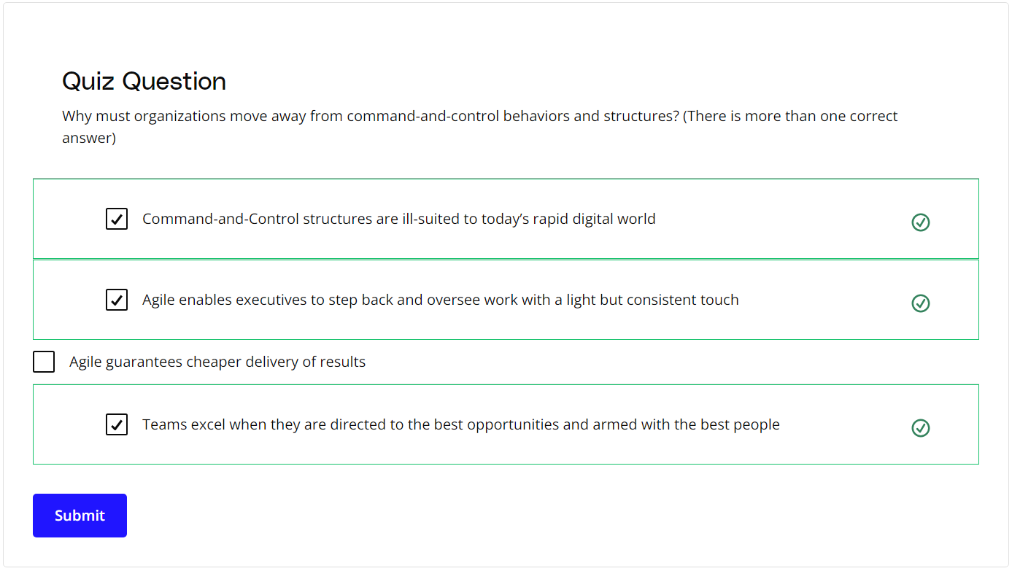

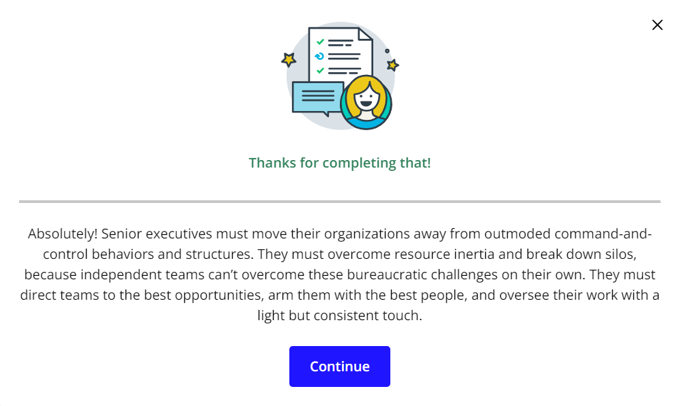

### **New Terms**

* **Innovation Hub**: Proactively working towards continual improvement with no compromise on technical excellence and quality
* **Self-Organized**: The team determines tasks and makes technical decisions about the work to be done after being given priorities by the Product Owner

### **Additional Resources**

* [**5 Ways to Organize Agile Teams**](https://www.scrumalliance.org/agile-resources/resources-for-your-agile-life/agile-advanced/may-2016/select-repost-5-ways-to-organize-agile-teams): This blog post from the Scrum Alliance describes five techniques to organize Agile teams successfully.

# How Experts Approach Agile Teams

## Thinking About Agile Teams

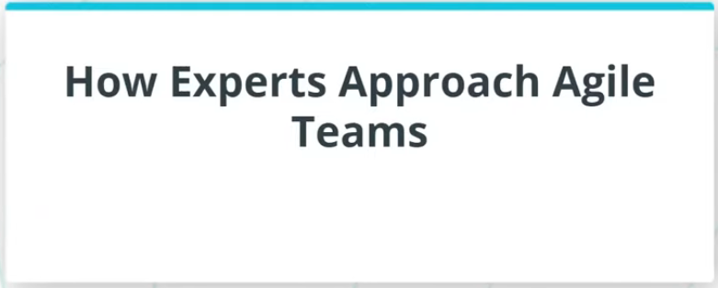

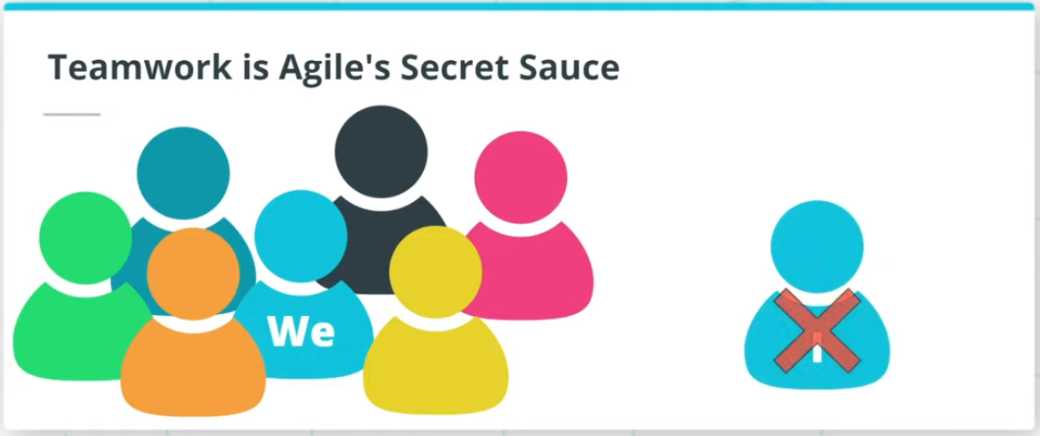

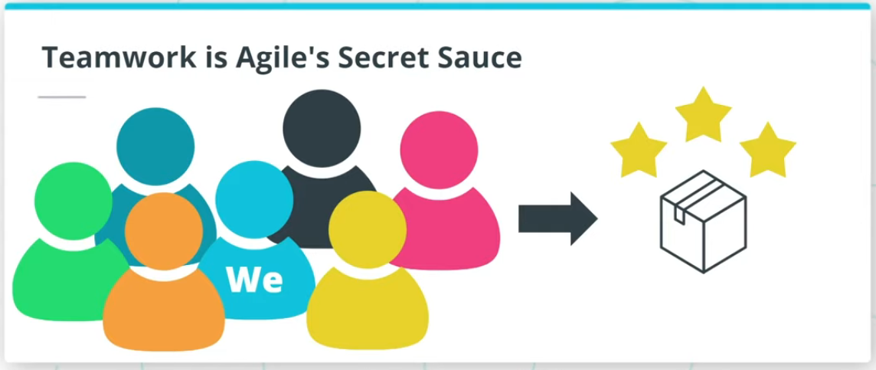

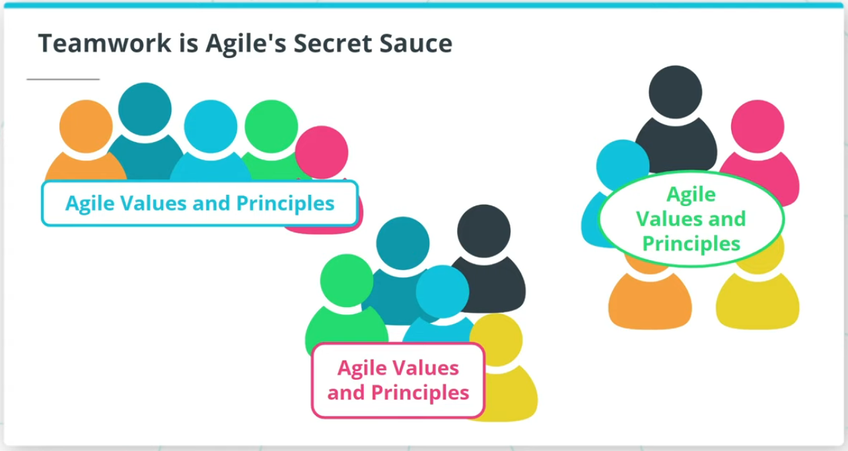

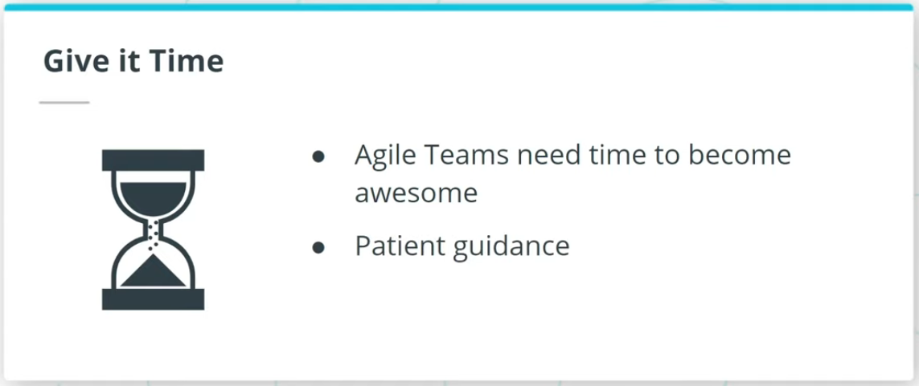

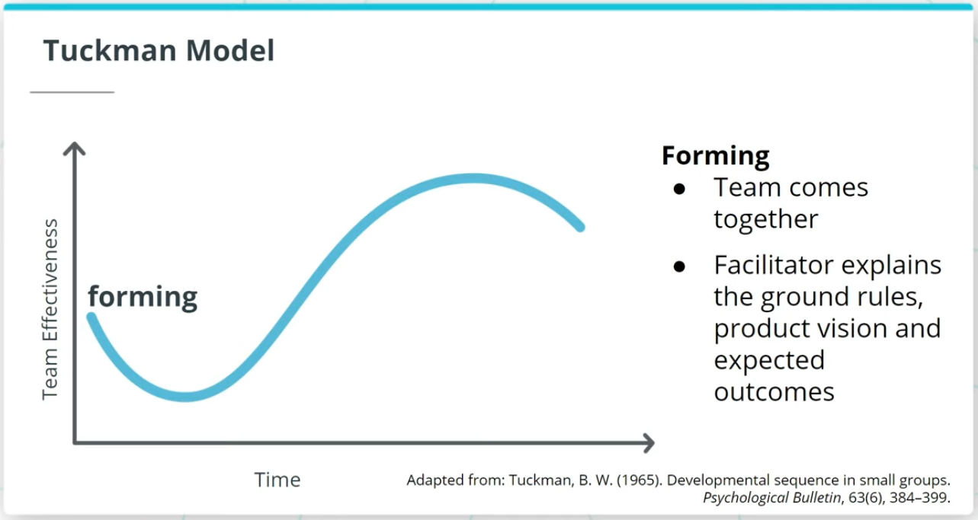

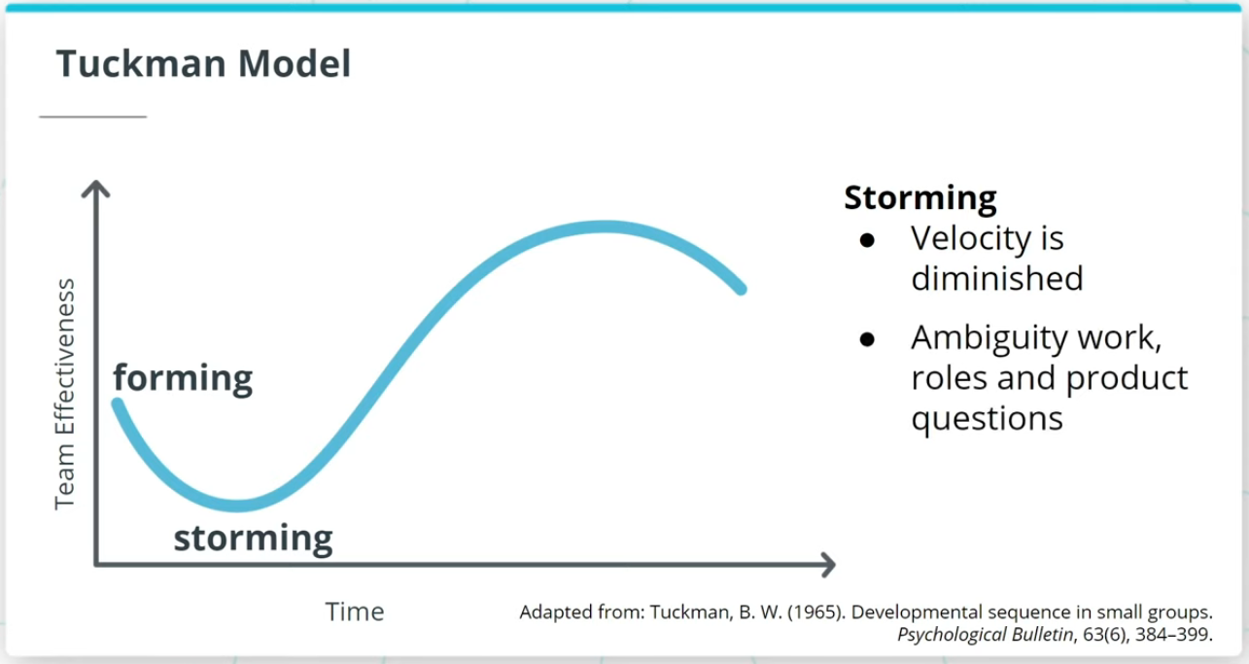

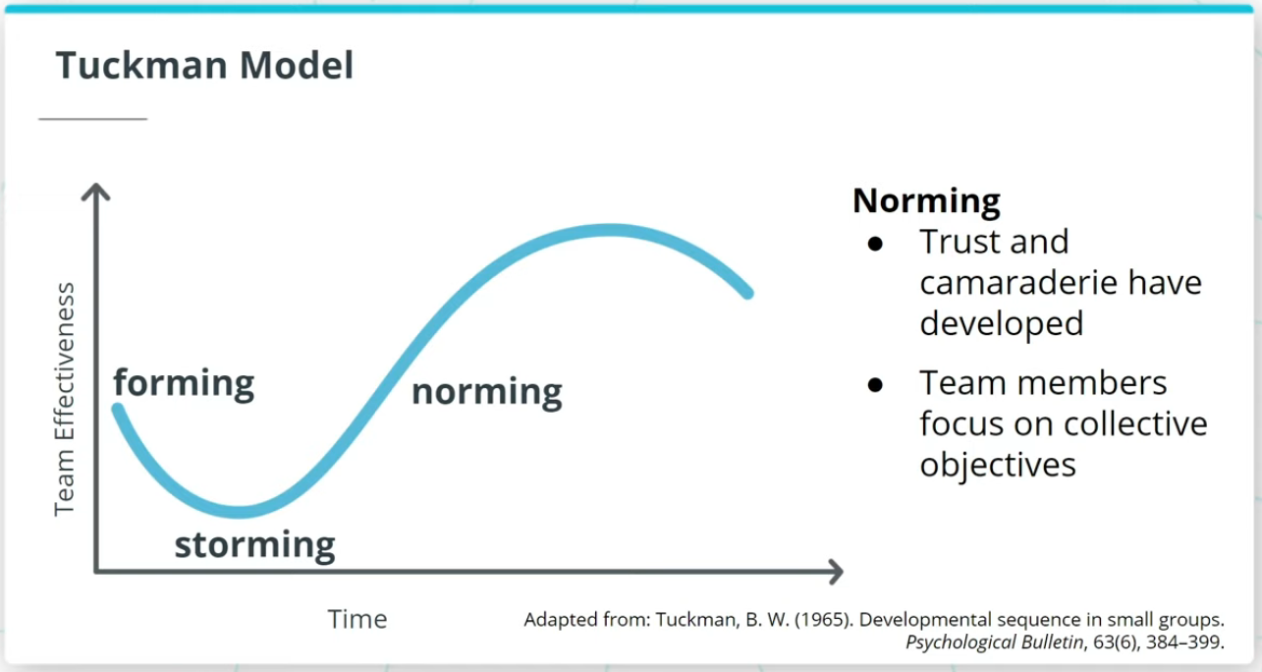

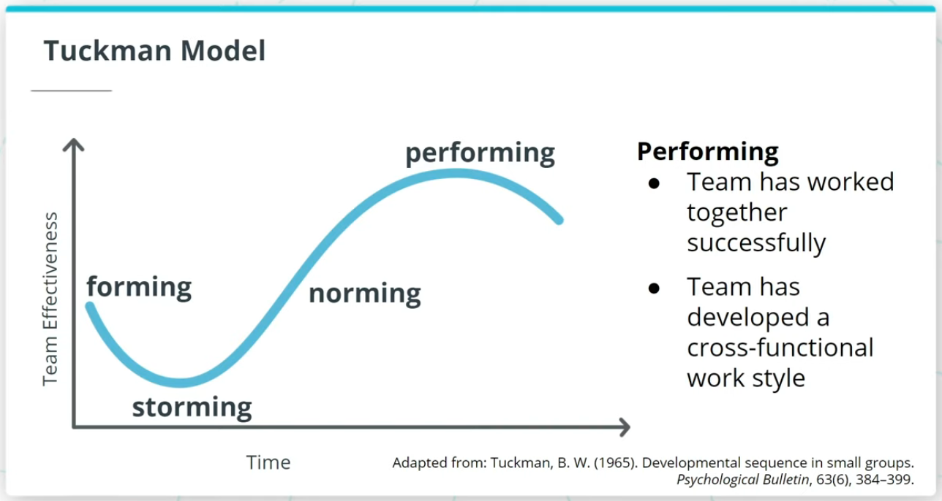

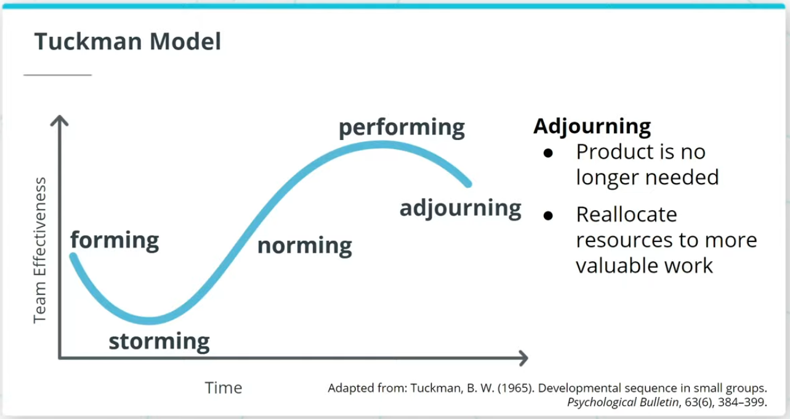

### **Key Points About High Performing Teams**

* Agilists believe that nothing is more critical to delivering exceptional products than teamwork.
* Agile Teams live and breathe the "we" mindset rather than “I."

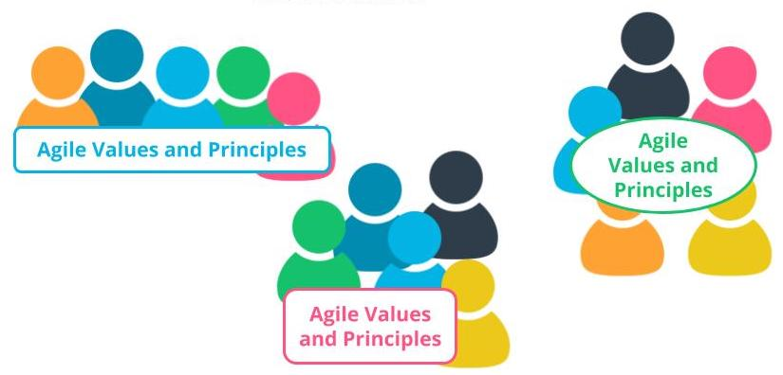

Teamwork is Agile's Secret Sauce

### **Tuckman Model**

The Tuckman Model, which has 5 stages of team development, describes how an Agile team progresses into an awesome Agile squad.

* **Forming** - Agile Team comes together and the Facilitator helps the team form by explaining the ground rules, product vision, and expected outcomes.
* **Storming** - This is where a team’s velocity is impacted because there tends to be some confusion and ambiguity around the work to be done, roles, and other product-related questions.
* **Norming** - Agile Team members develop a sense of trust and camaraderie. There’s a healthy rapport and each team member starts to look for the collective objectives of the team’s long-term success.
* **Performing** - Once an Agile Team has successfully worked together over a few iterations they should be in a state where they have gelled together and developed a strong cross-functional work style.
* **Adjourning** - If the business leaders realize that a product is not delivering value or is no longer needed in the market, the existing Agile Team members can be re-allocated to other more valuable work in the organization.

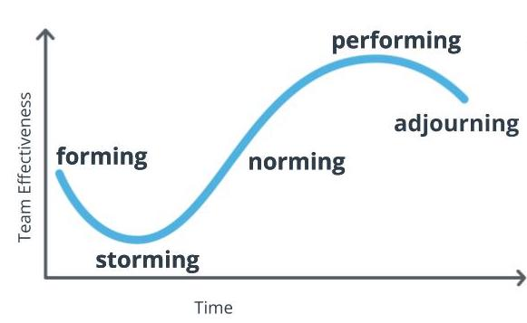

**The Tuckman Model**  
Adapted from: Tuckman, B. W. (1965). Developmental sequence in small groups. Psychological Bulletin, 63(6), 384–399.

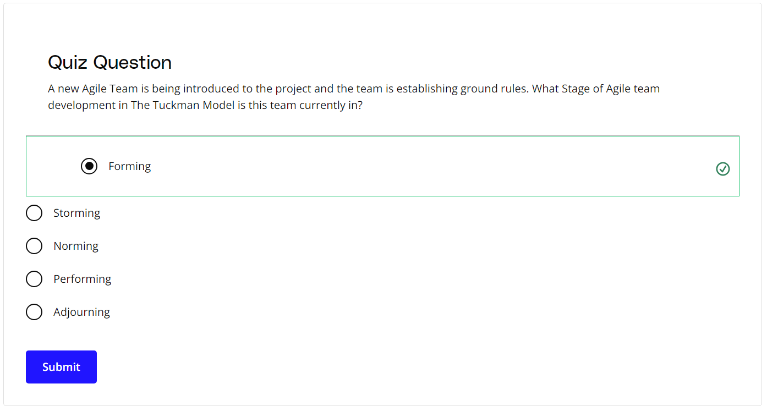

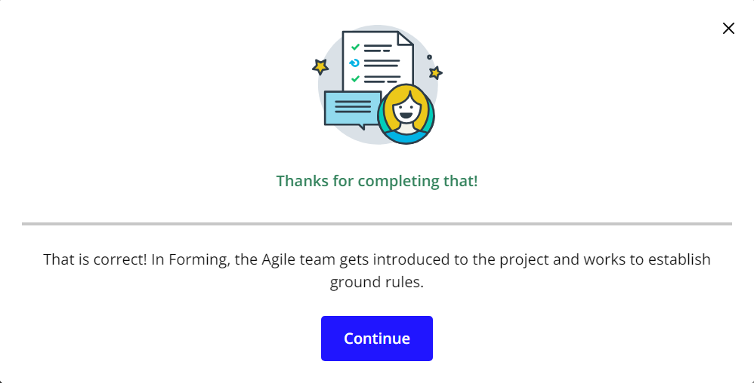

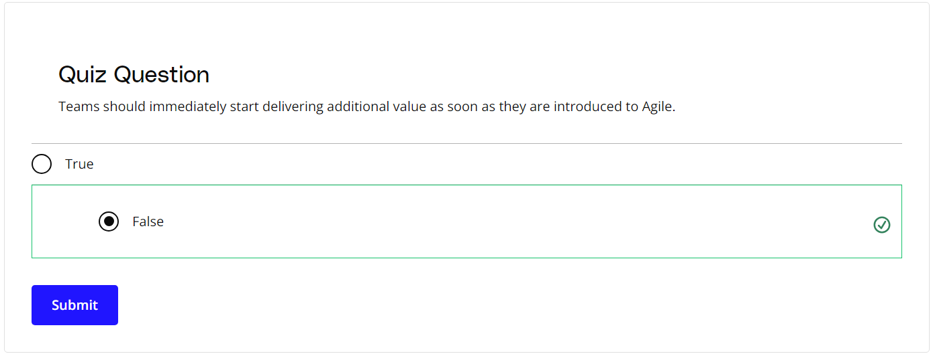

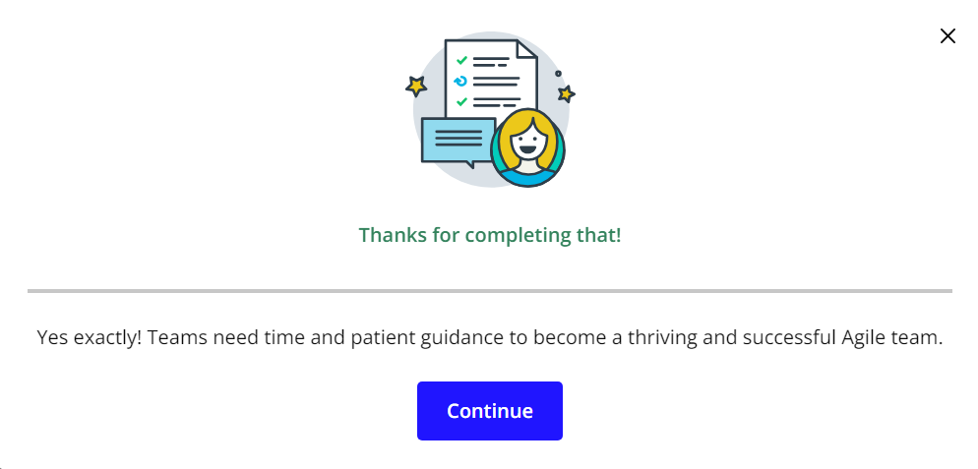

### **New Terms**

* **Adjourning**: The stage in the Tuckman Model where the Agile team’s goals have been completed, and the focus is on wrapping things up before team members get reassigned to other work
* **Forming**: The stage in the Tuckman Model when the team is getting accustomed to each other, ground rules are being established, and everyone is informed of the goals and objectives
* **Norming**: The stage in the Tuckman Model where a sense of trust develops among team members; interpersonal differences are taken care of now, and a sense of collaboration for the team's collective benefit arises
* **Performing**: The stage in the Tuckman Model where the team has matured into a well-established unit with a sharp focus on collaborative value delivery
* **Storming**: The stage in the Tuckman model where the team goes through a level of chaos in which there is confusion around the goals and objectives of the project, as well as confusion around roles and responsibilities

### **Additional Resources**

* [**High-Performance Teams - Why the Who Matters Less**](https://www.scrumalliance.org/agile-resources/resources-for-your-agile-life/agile-advanced/march-2017/high-performance-teams-why-the-who-matters-less): Fabian Schwartz discusses how the collective team is more important than having superstars on board.
* B W Tuckman, ***Developmental Sequence in Small Groups***, Psychological Bulletin 63, 1965.  
  This is where Bruce Tuckman first introduced the Tuckman Model.

# Three Core Roles

## What Are the Three Core Roles?

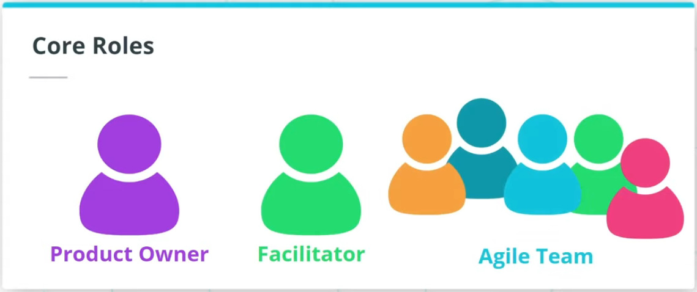

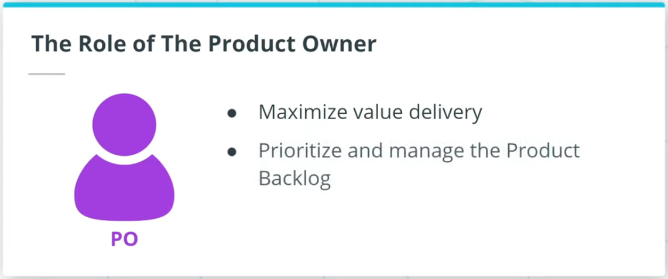

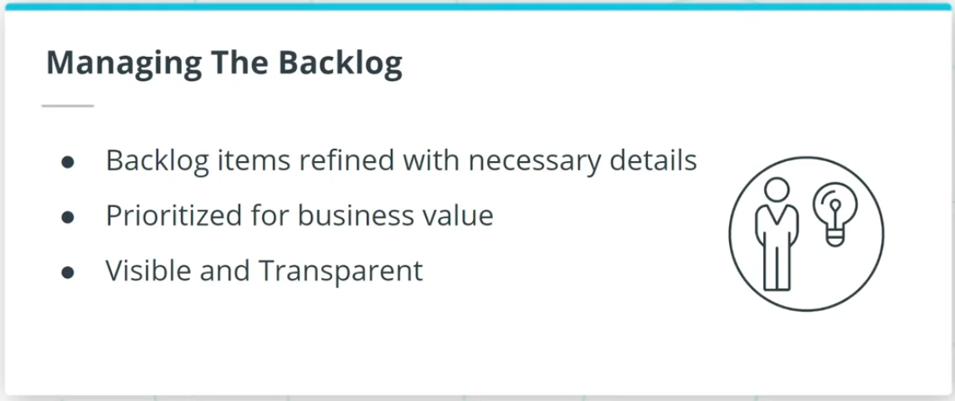

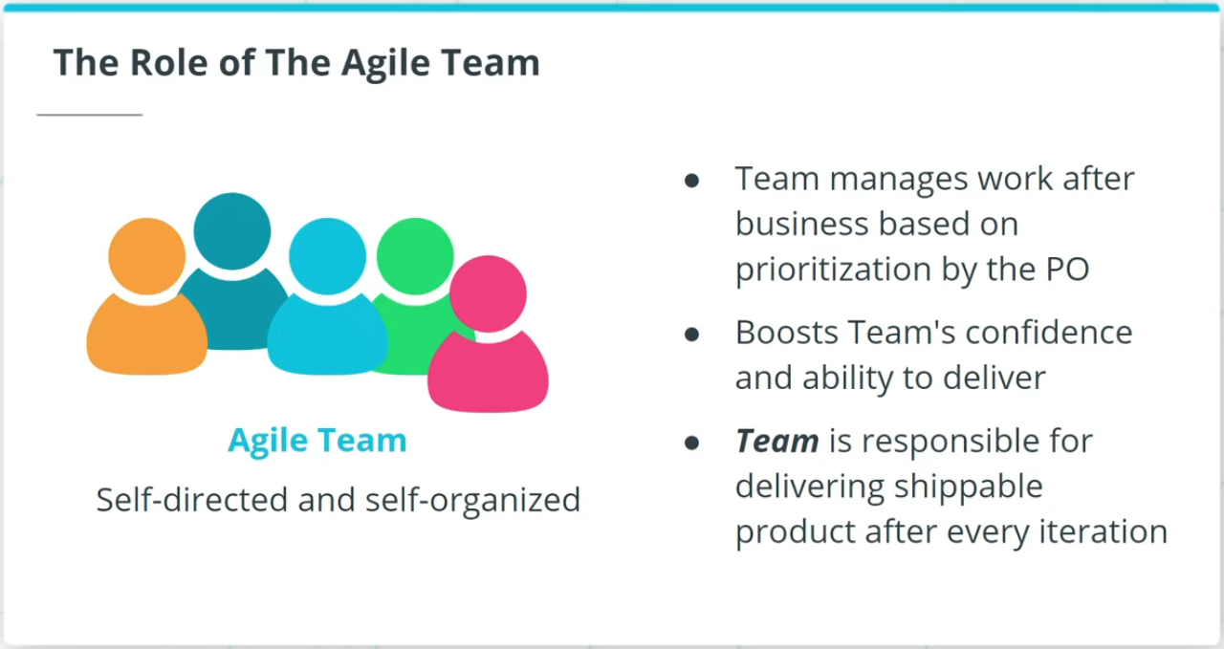

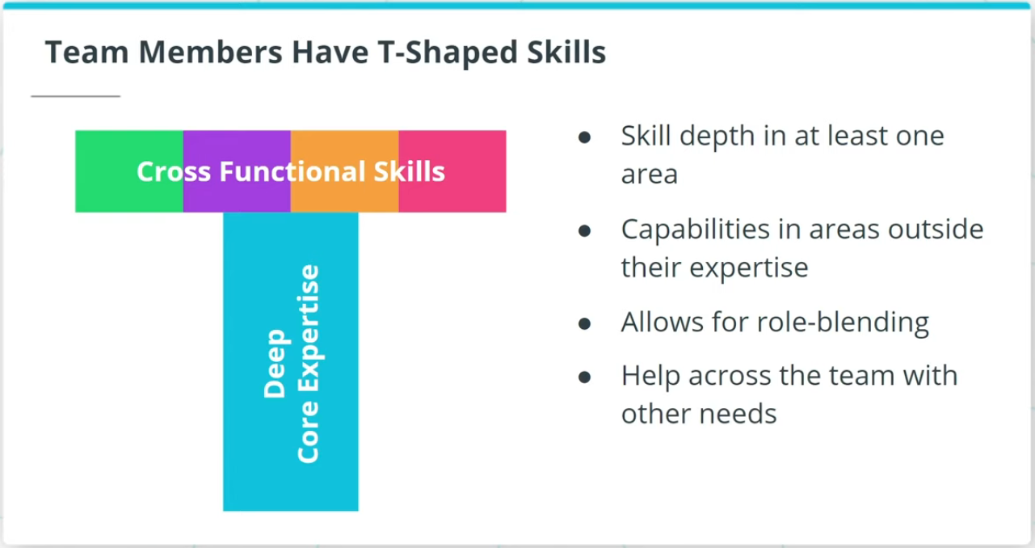

### **Three Core roles in Agile Frameworks: Product Owner, Facilitator, and Agile Team**

* A **Product Owner**, often referred to as PO in short, is responsible for working with both The Agile Team as well as the business to maximize the value of the product deliverables being worked on. The Product Owner is primarily responsible for prioritizing and managing the Product Backlog, or the prioritized work item list.
* **Agile Teams** are self-directed and self-organized. The Agile Team members are the ones who accomplish the actual work of completing and delivering a potentially shippable version of the product at the end of each Iteration.

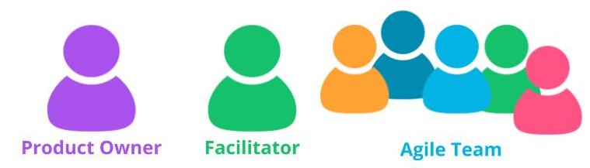

Three Core Roles in Agile

### **Agile Team Members Exhibit T-Shaped Skills**

When Agile Team members exhibit T-Shaped skills:

* They have tremendous expertise in at least one area.
* They are also capable of providing value in other areas outside their expertise.
* Team members are able to do role blending by going beyond their core vertical skill set.

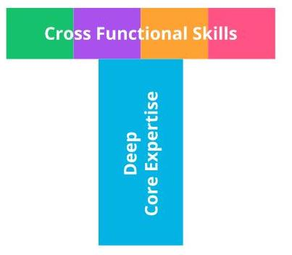

Agile Team Members Exhibit T-Shaped Skills

## Facilitator As Servant Leader

### **To Serve and Support**

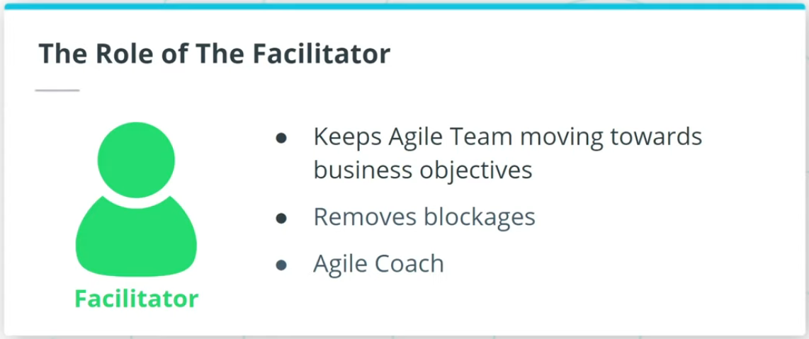

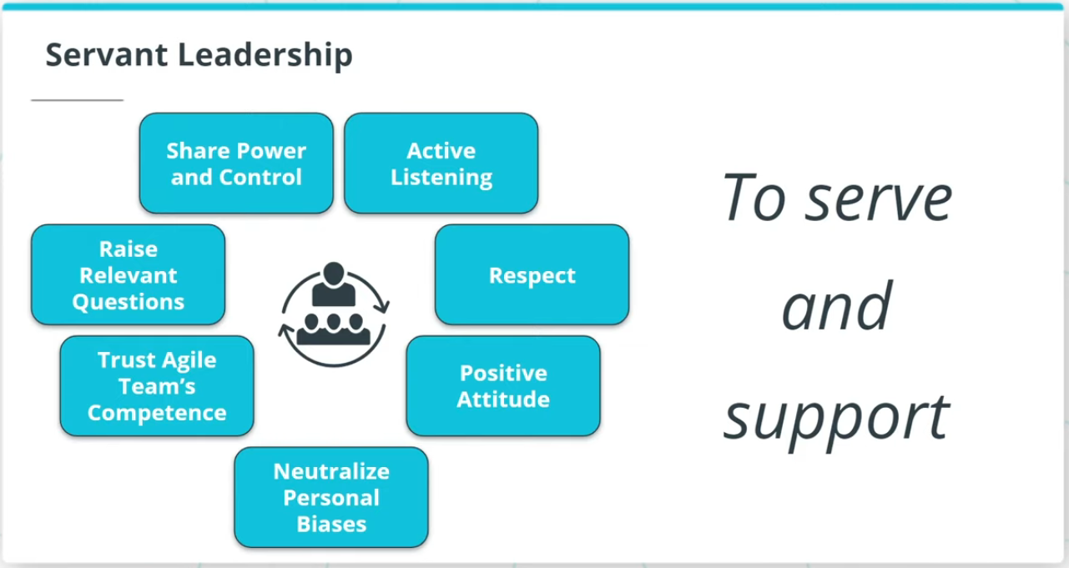

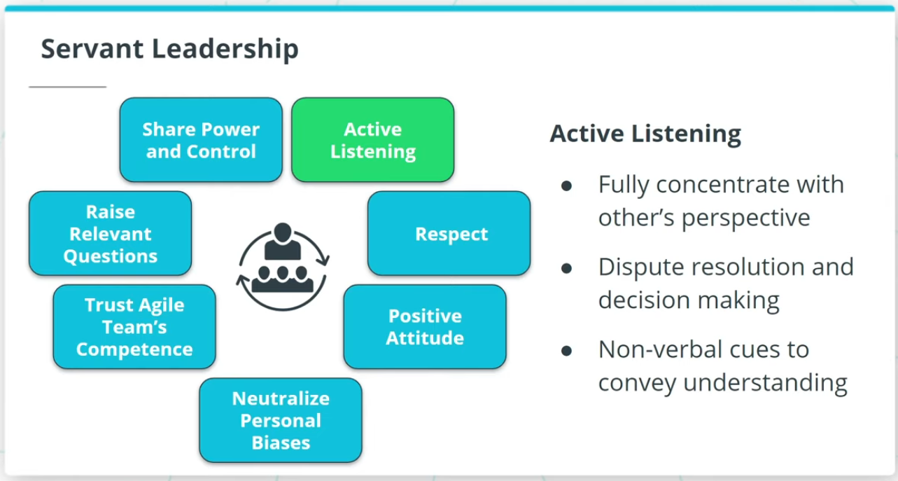

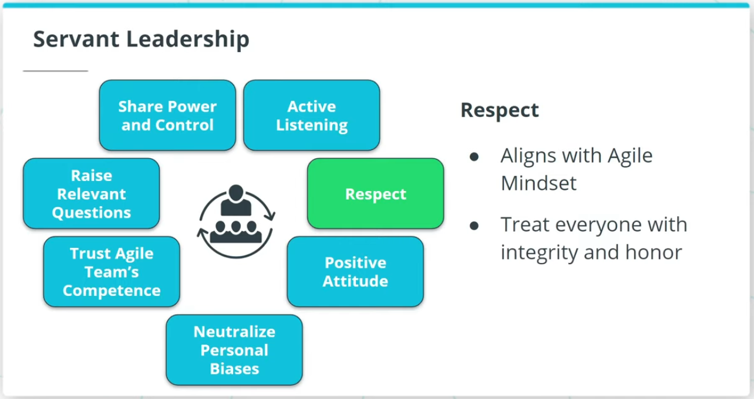

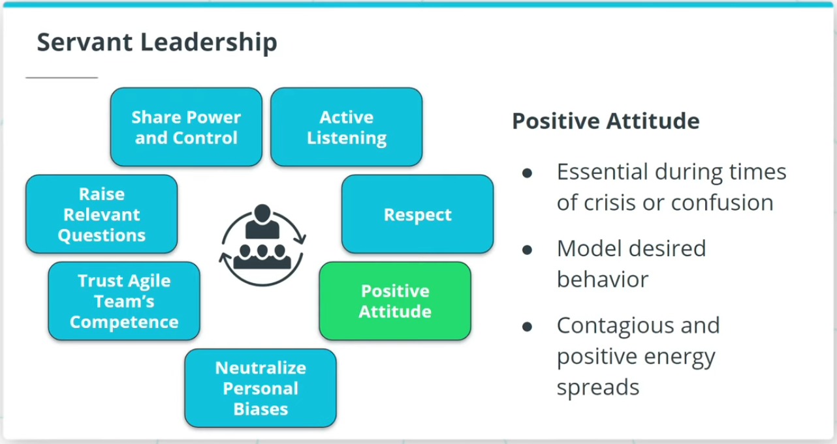

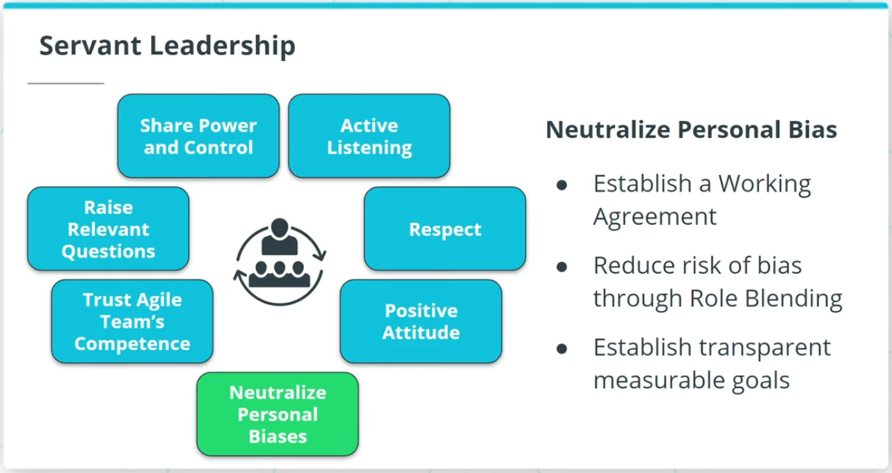

The Facilitator is responsible for ensuring the Agile Team moves along at an acceptable pace. The Facilitator is also usually an Agile Coach who promotes Agile practices and values.

### **Facilitators are Servant Leaders Who Serve and Support**

Servant Leadership adopts a leadership viewpoint in which the leader positions himself or herself to serve and support. Servant Leadership includes:

* Active listening
* Respect
* Positive attitude
* Neutralize personal biases

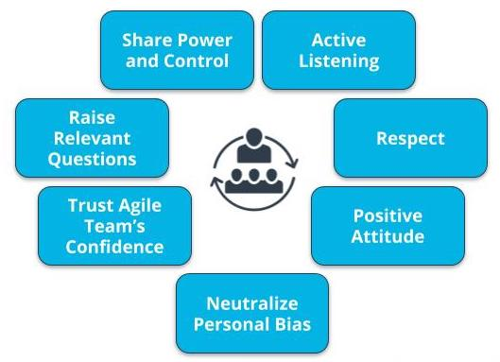

Characteristics of Servant Leadership

### **Servant Leadership Helps the Team Deliver Results**

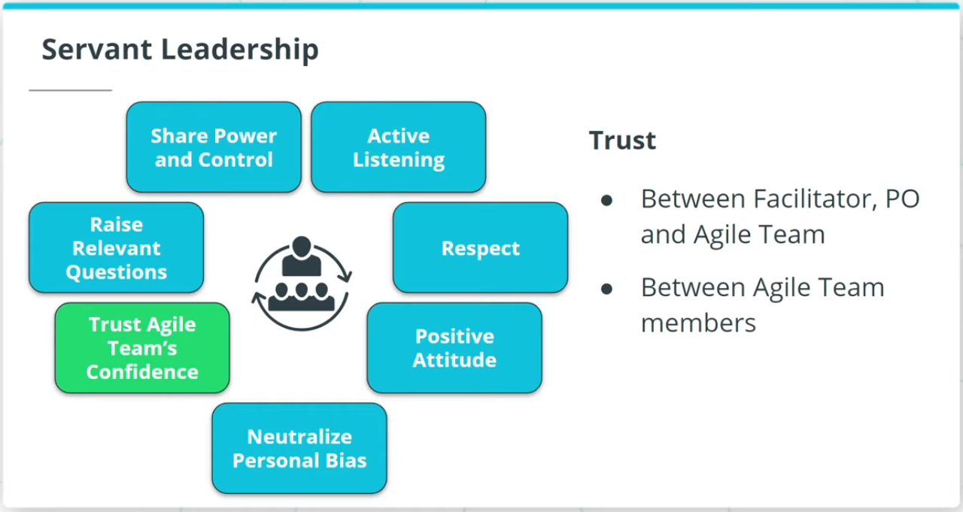

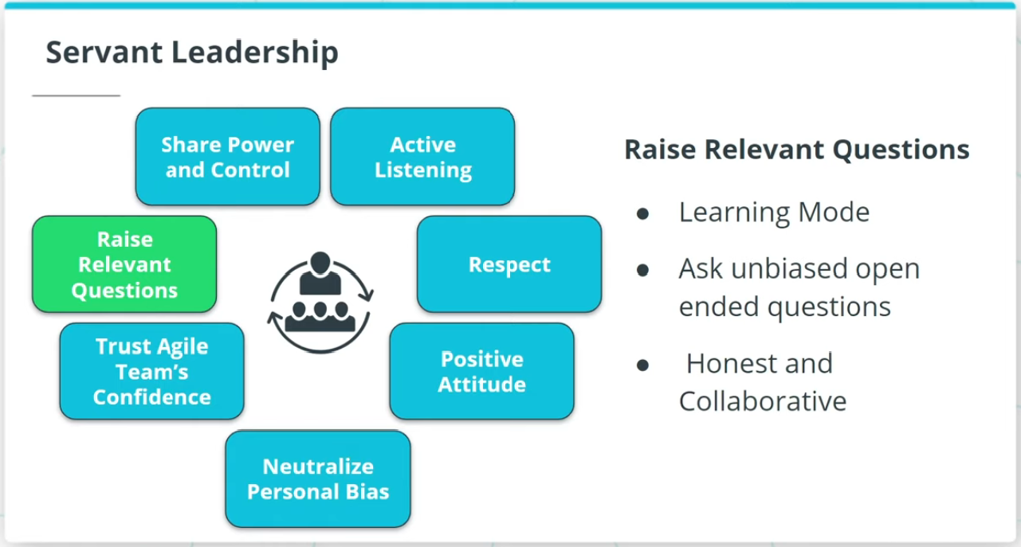

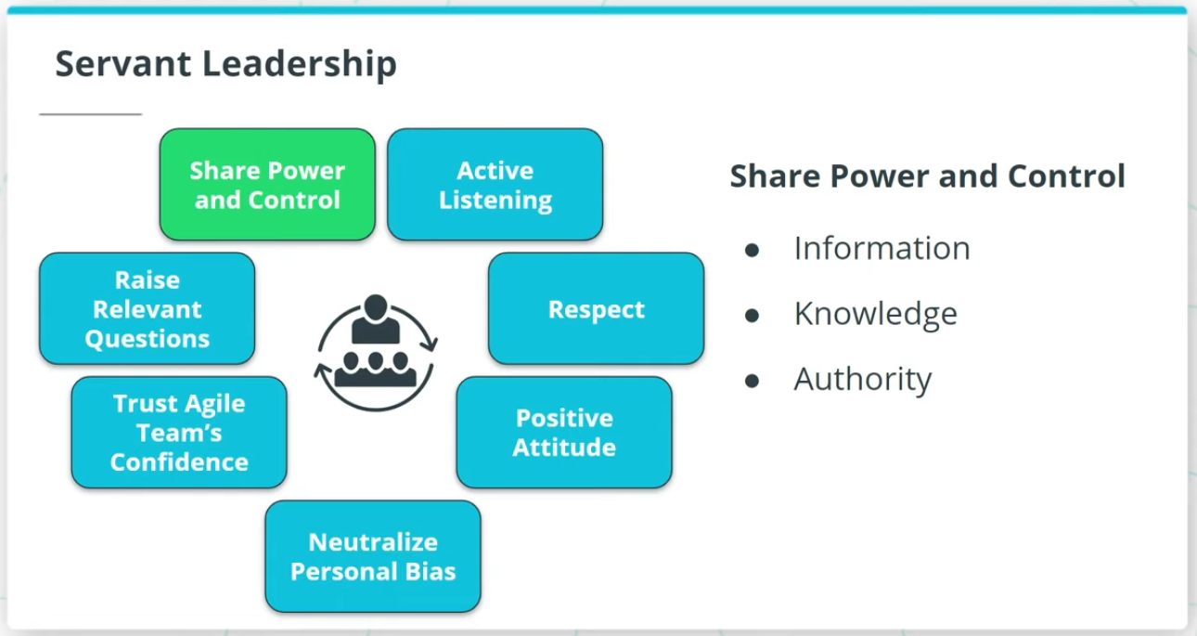

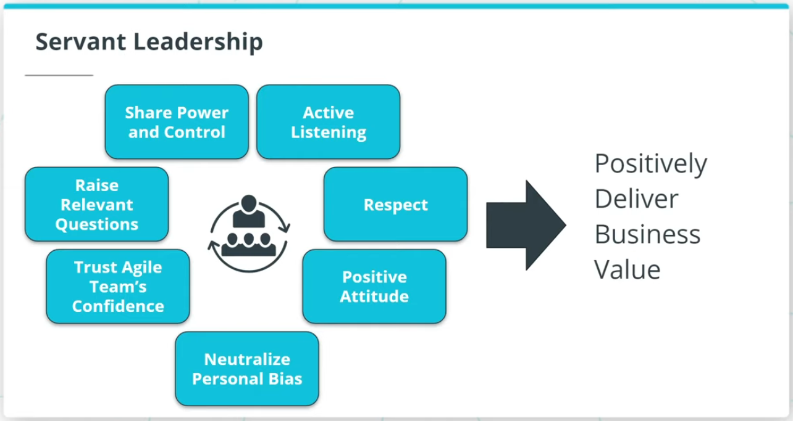

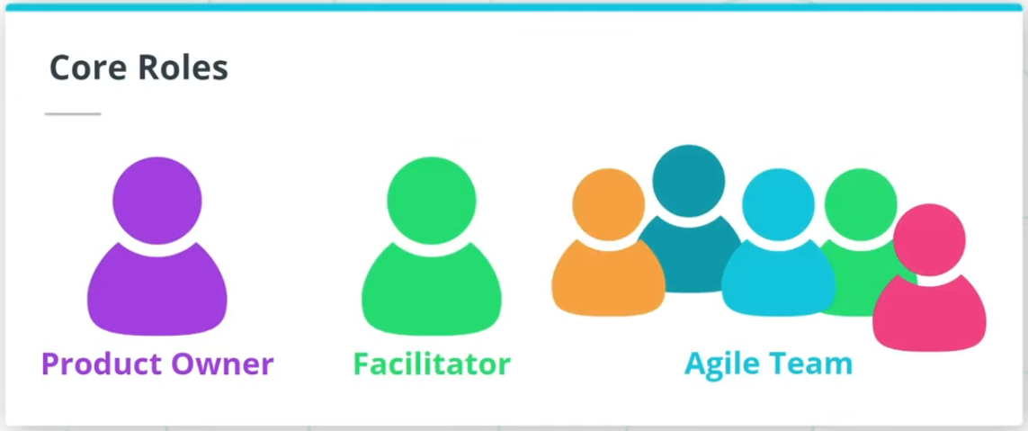

Servant Leadership also includes:

* Trust Agile Team’s competencies
* Raise relevant questions
* Shares power and control

Servant Leadership helps a Facilitator build a high-performing Agile team, which in turn enables the Facilitator to truly help the Agile Team achieve results that positively deliver business value.

### **New Terms**

* **Facilitator**: The person who ensures that the Agile Team moves along at an acceptable pace towards the business objective and removes any blockages or impediments that may be slowing the team
* **Self-Directed**: Team members are empowered to decide among themselves who does what and how it is to be accomplished in a collaborative manner
* **T-Shaped Skills**: A strong vertical skill combined with the capability and willingness to step into other cross-functional needs
* **Team Member**: The people who accomplish the actual work of completing and delivering a potentially shippable version of the product at the end of each iteration

### **Additional Resources**

* [**The Elusive Product Owner**](https://www.scrumalliance.org/agile-resources/resources-for-your-agile-life/agile-advanced/march-2016/select-repost-the-elusive-product-owner): This Scum Alliance post discusses the critical role POs play in Agile teams.

# Quizzes: Three Core Roles

## Thinking About the Three Core Roles

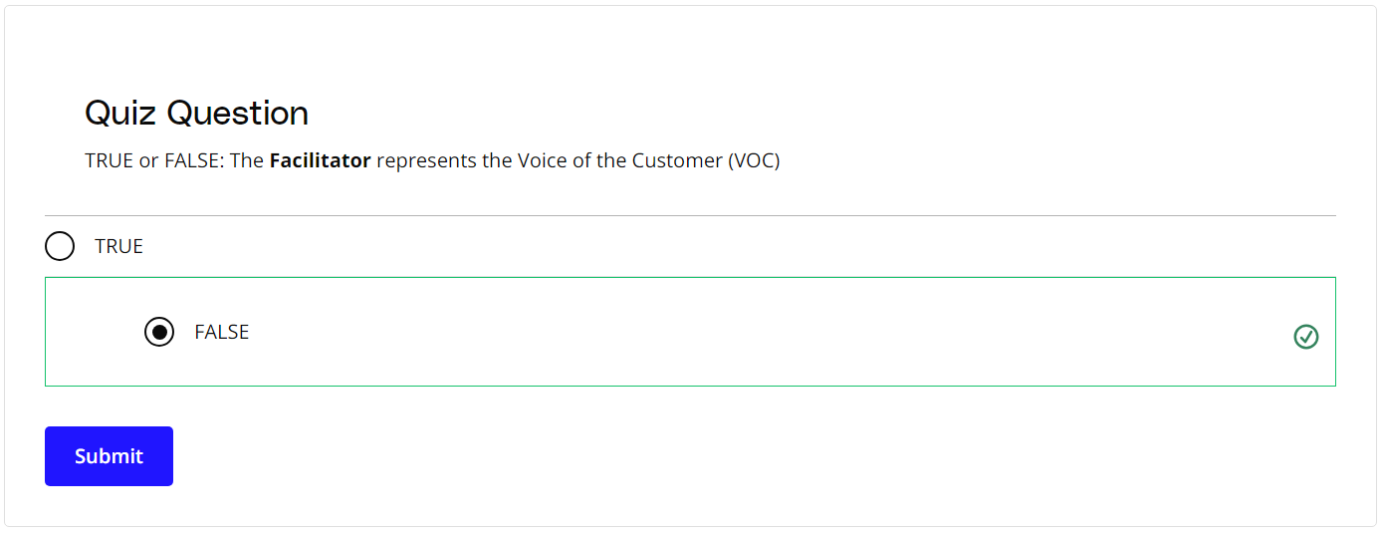

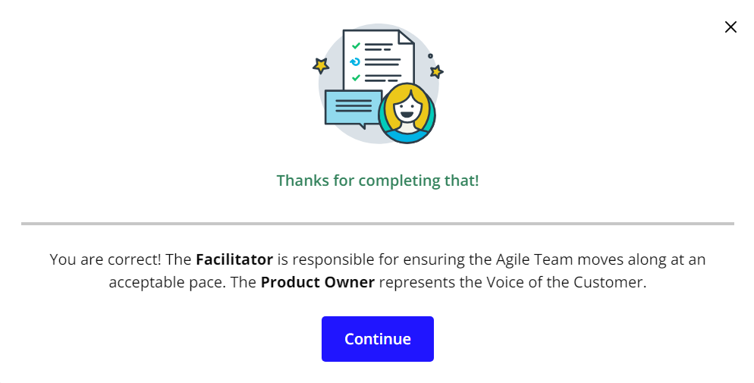

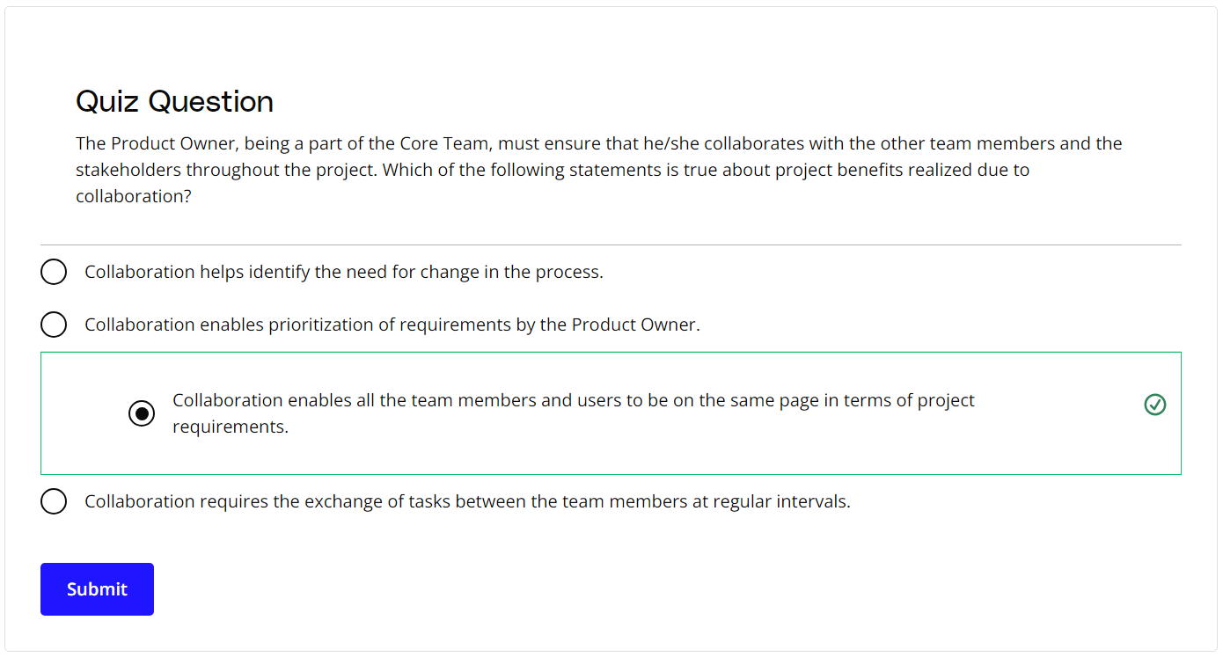

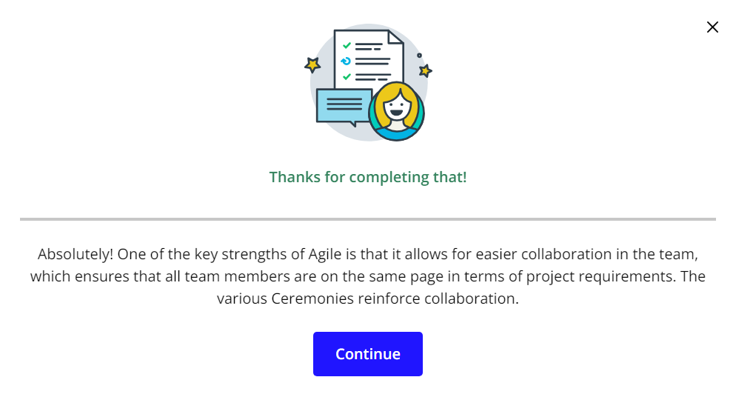

# Exercise: Three Core Roles

## Assigning the Three Core Roles

As SocialKare.gov starts on its Agile transformation, the team will need to fill the core Agile roles.

Review the [**SocialKare.gov Case Study**](https://video.udacity-data.com/topher/2020/September/5f5f6bc7_agnd-c1-foundations-of-agile-socialkare.gov-case-study/agnd-c1-foundations-of-agile-socialkare.gov-case-study.pdf) and

* Identify the three Agile Core roles and their responsibilities in the SocialKare.gov context
* Assign one of the listed SocialKare.gov employees to the Core Agile Roles
* Explain your assignments



### **Key SocialKare.gov Employees**

This information also is available in the [**SocialKare.gov Case Study**](https://video.udacity-data.com/topher/2020/September/5f5f6bc7_agnd-c1-foundations-of-agile-socialkare.gov-case-study/agnd-c1-foundations-of-agile-socialkare.gov-case-study.pdf).

* **John Details**: John is a detail-oriented individual who likes to plan everything out in tremendous detail. He has several years of experience as a Technical Project Manager. Prior to stepping into the role of Project Manager, John was a Developer. He is known to have good communication skills.
* **Sarah Tenure**: Sarah has been with the Agency responsible for launching SocialKare.gov for over 2 decades. Sarah has a lot of business knowledge and carries a certain amount of credibility due to this tenure. Sarah is strong-headed and likes to make decisions based on how she sees things because she believes she has better insight than others who may have been with the organization for as long as she has.
* **Tim Devs**: Tim has excellent technical skills. He prefers working as an individual contributor where he can spend time diving into the technical challenges on his own. He is well respected for his technical expertise. Tim maintains a strong focus on technical delivery and prefers the business users to stay out of his way while he is working through the development work. Tim leads a team of 5 developers with specialized vertical skills who are also on this project team
* **Jane Dollars**: Jane has sponsored this project. She is a senior executive and likes to stay involved with the day-to-day activities of projects that she sponsors.

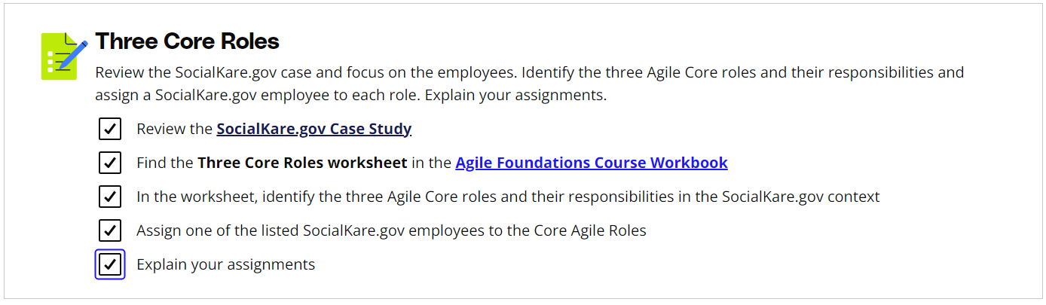

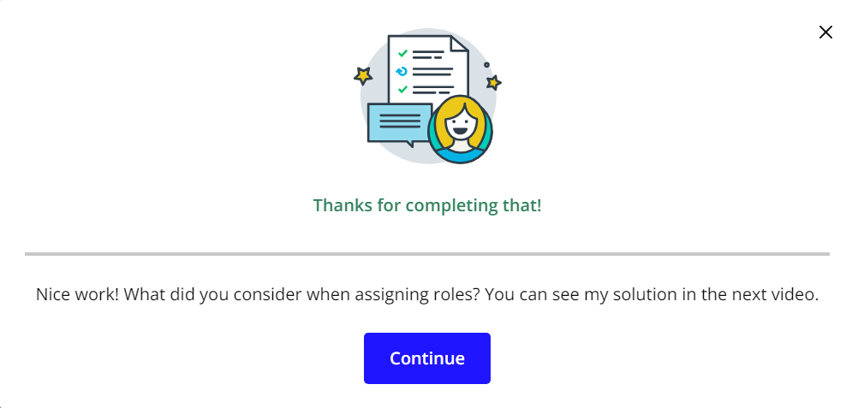

# Solution: Three Core Roles

## My Solution

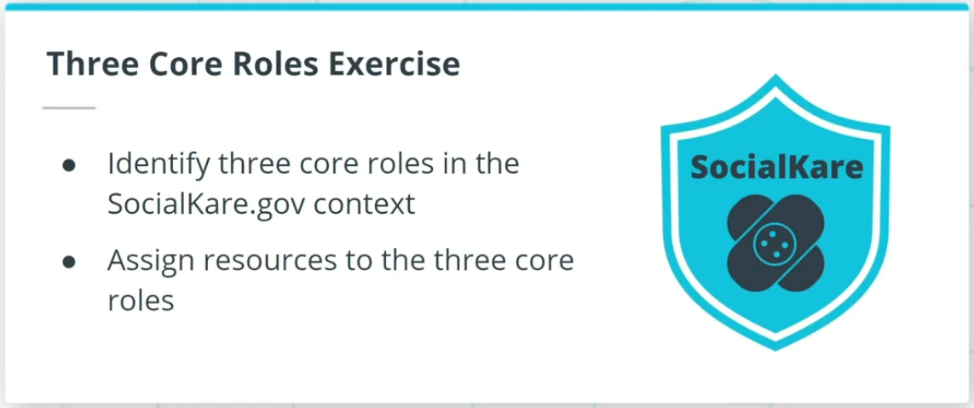

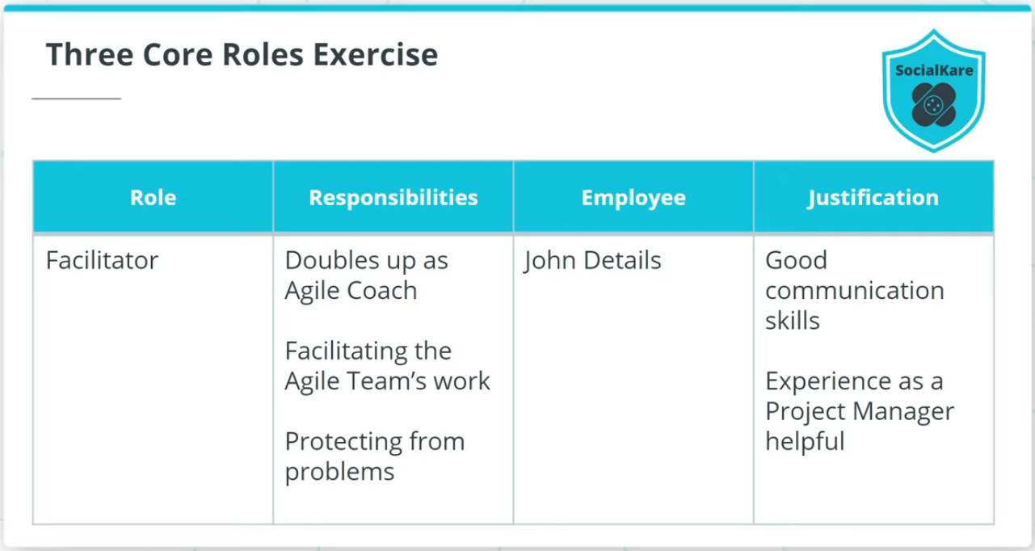

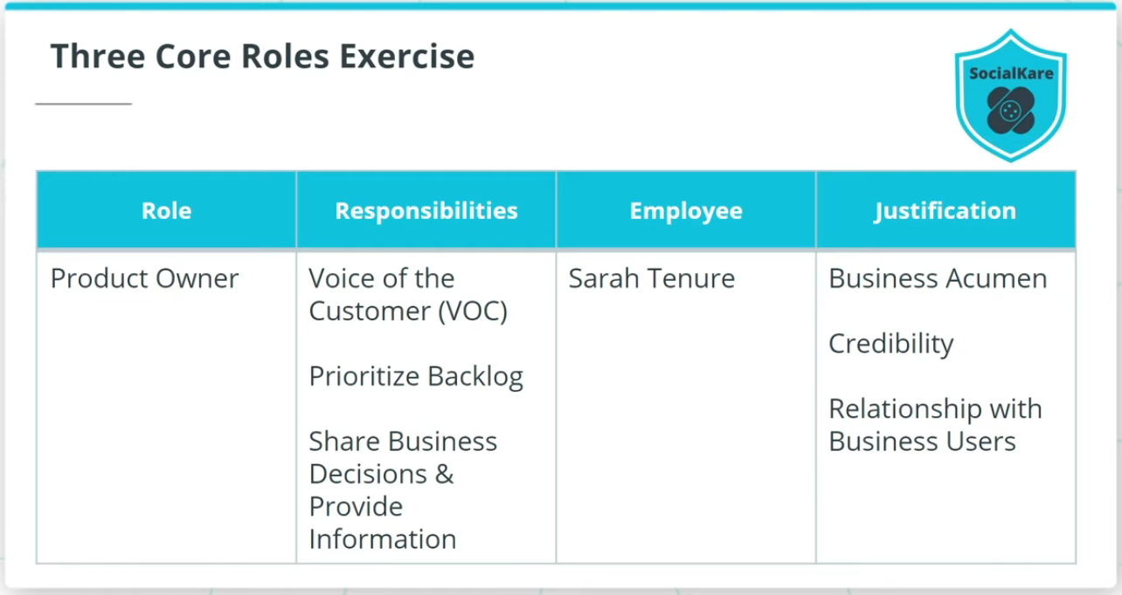

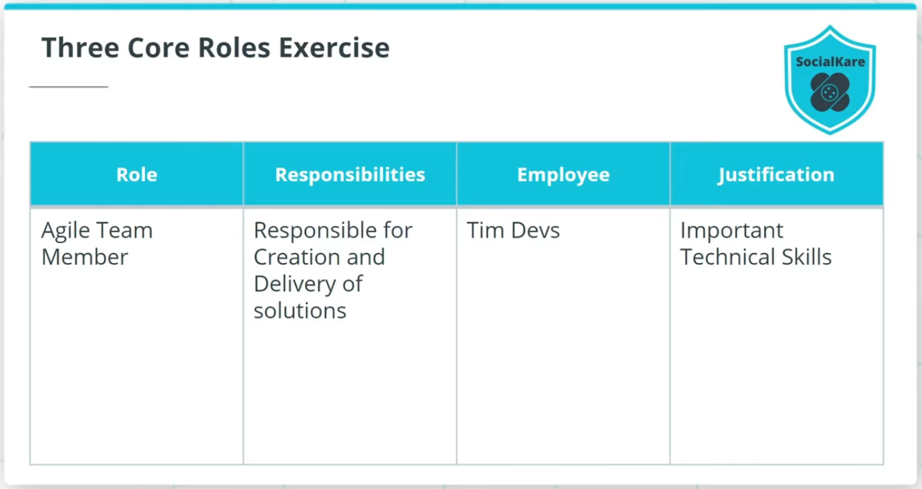

### **Identify the Three Agile Core Roles and Responsibilities for the SocialKare.gov Team**

* **Facilitator** - Can double up as an Agile Team coach or project lead at SocialKare.gov, is responsible for facilitating the Agile Team’s work, obtaining resources for it, and protecting it from problems. The recommended employee is ***John Details***.
* **Product Owner** - Represents the SocialKare.gov stakeholders and specifically is known as The Voice of the Customer (VOC); the one individual who is responsible for the prioritized work item list, called a Product Backlog; will be responsible for prioritizing the backlog, share business decisions in a timely manner, and for providing any requirements or functionality related information to the Agile Team in a timely manner. The recommended employee is ***Sarah Tenure***.
* **Agile Team Member** - Primarily includes developers who are responsible for the creation and delivery of a system; However, all other Agile team members will also be included in this category. This includes, but is not limited to, those who will conduct modeling, programming, testing, business analysis, front-end design, release activities, and others. The recommended employee is ***Tim Devs***.

